Analysis 3

Introduction
In this analysis I will be exploring new methods of feature extraction.
- Common Spatial Pattern (CSP) which takes in time series and converts it to feature vector
- Counter measures to non stationary signal
  - Z-score normalization
  - Differential features
    - Differentials between base line window vs active window
    - Differentials between left and right side of brain
- Frequency Domain
  - Extracting relevant intrinsic mode functions from Empirical Mode Decomposition (EMD) and applying HHT.

Trying CSP + SVM
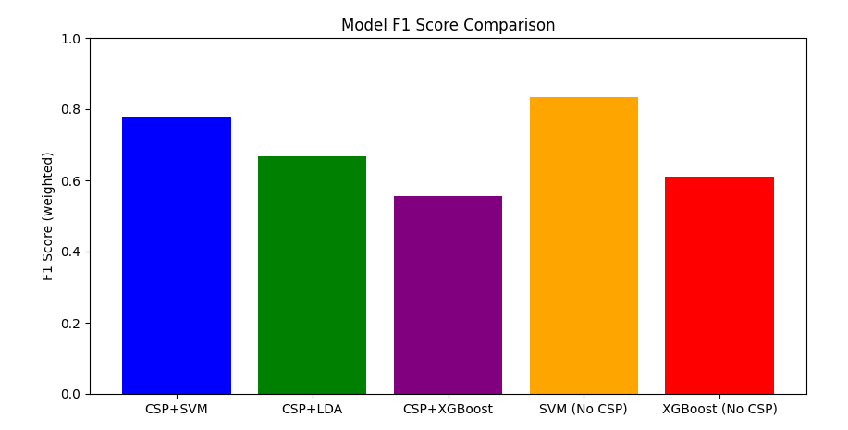
Currently SVM without CSP features performs the best.

